[17/02/2023], [Wamasaa Investment Sacco]

Project Proposal: **[A STUDY AND DEVELOPMENT OF AN ONLINE BUS TICKETING SYSTEM ]**

**Background**

People used to frequently relocate for long periods of time before the advent of modern transportation and communication technologies. Thanks to today's advanced and efficient transportation options, you may travel great distances and communicate with people from all over the world in a matter of seconds.

It's clear that transit option is crucial. We are currently in the "information age," characterized by an explosion in the production, storage, and dissemination of data. Thus, managers and other information consumers, especially in the transportation industry, wish for additional forms of data to assist in running their businesses. So, it's up to them to handle the growing mountain of data and information that needs to be managed.

Companies in today's dynamic environment need to develop innovative approaches to the management of the complexities inherent in their rapid growth and existence. As a result of the global COVID-19 outbreak, health organizations everywhere instituted precautionary measures, compelling businesses to find ways to continue providing excellent service despite having to rely less on human labor. This meant that businesses had to use technology to oversee day-to-day tasks.

Kenya's government made use of the country's topography to construct the Nairobi Expressway, which runs from Mlolongo to James Gichuru in Westlands. Compared to alternative methods, this one is both faster and more direct.

One of the most important centers for public transportation in Kenya, the Wamasaa Investment Sacco, was established to meet the needs of the country's growing population of people who rely on public transportation. The Sacco had to figure out how to get its customers where they needed to go, even if it wasn't quite the same place.

**Objectives**

Bus ticket reservations are currently being managed by the sacco manually, which is a time-consuming process. Since it involves the transportation industry's ticket booking and transport maintenance, the job of the ticket booking transporter can become quite laborious if they aren't careful. The bus ticket reservation system not only handles transporters' own fleet of vehicles, but also accounts for the many types of system transport vehicles made available by other transporters.

1. The goal of this project is to create a piece of software that will automate the processes involved in booking flights and other travel arrangements for travel agencies.
2. With this technology in place, the project team and the staff at the Ticket Booking Agency can process more ticket orders in a given period of time.
3. In order to make this system project accessible to people with varying levels of technical expertise, we've taken great care to ensure that it's as straightforward as possible to use.
4. Bus ticket booking and cancellation information will be maintained in a central database on the computer's hard drive, making the task of booking tickets much more efficient.
5. The most recent data on the system's performance status and other questions.
6. The purpose of my project is to improve the method for purchasing tickets through the Ticket Booking Agency more streamlined, trustworthy, user-friendly, and error-free. Also, it takes a lot less time than doing things by hand.

**Scope**

This research focuses on two parties, i.e. the bus operators and the customers. A number of these bus operators are also the system administrators of this system as well. They are able to add, edit and retrieve information and generate reports to assist them with their daily operations. This back-end activities will help the bus operators to evaluate its current position and to plan its company’s operations on how and what action to be taken in order to stay ahead in this competitive business world.

The back-end activities mentioned above are the sales/business performance, public opinion through online voting and finally the bus operator’s commitment of maintaining good track records according to the policies of governing bodies. These back-end activities will be the pillar for creating the competitive edge to a bus operator to spear- head in providing better service to a customer in this challenging business environment.

The customer will be able to utilize this Online Bus Ticketing System software to

perform their transaction of purchasing bus tickets at their own hassle free time. The

features that are available in this system will mostly reflect from the survey conducted

during the data sampling stage. In this business competitive era, Information Communication Technology (ICT) is placed on a platform by many organizations as their key indicator for success. Online data handling has been a major tool to provide better customer service.

By adapting ICT as a tool to provide the bus operator’s management, it will not only improve operations efficiency, gaining competitive advantages, delivering higher-quality services, but it will also lead an organization to superior control over the booking process which will allow the customers to choose their services from other competitors. Thus, by developing the Online Bus Ticketing System web portal between inter-cities, the bus operators will have no choice but to join the bandwagon to stay ahead with ICT to improve its services and finally this will cause a reduction of human traffic in Nairobi.

**Timeframe**

|  | Task | Start and End Dates |
| --- | --- | --- |
| Phase One | Project Plan, Plan Review | Dec 12th - Jan 3rd 2022 |
| Phase Two | Data Requirements, Project and Acceptance Test Plan, Final Requirements Specification, Phase Review and Approval. | Jan 3rd - March 1st 2022 |
| Phase Three | Draft Design Specifications, Architecture design plans, Define Interface Requirements, Integration Test Plan, Final Design Specifications, Phase Review and Approval. | Feb 4th - April 8th |

**Project Budget**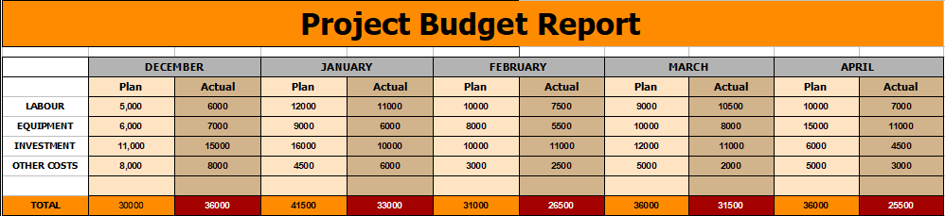

**Key Stakeholders**

| Client | Wamasaa Investment Sacco |
| --- | --- |
| Sponsor | Wamasaa Investment Sacco |
| Project manager | Laurence Magondu Mureithi |

**Monitoring and Evaluation**

This system development uses the concepts of agile methodology to release the software in iterations. This methodology for system development allows for quick testing as the project system is managed in iterations. For this cause, developers are able to find and fix defects as well as make frequent changes to the system.

**Approval Signatures**

|  |  |  |  |  |
| --- | --- | --- | --- | --- |
| [Wamasaa Investment Sacco], Project Client |  | [Wamasaa Investment Sacco], Project Sponsor |  | [Laurence Magondu Mureithi], Project Manager |

This Project Proposal Form is created for you by the simple project management tool[**www.casual.pm**](http://www.casual.pm)